**WEEK 3**

**Exercise 1: Configuring a Basic Spring Application**

**Scenario:**

Your company is developing a web application for managing a library. You need to use the Spring Framework to handle the backend operations.

**BookRepository.java**

**package** com.library.repository;

**public** **class** BookRepository {

**public** **void** saveBook(String title) {

System.***out***.println("Saved book: " + title);

}

}

**BookService.java**

**package** com.library.service;

**import** com.library.repository.BookRepository;

**public** **class** BookService {

**private** BookRepository bookRepository;

// Setter for Spring to inject dependency

**public** **void** setBookRepository(BookRepository bookRepository) {

**this**.bookRepository = bookRepository;

}

**public** **void** addBook(String title) {

System.***out***.println("Adding book: " + title);

bookRepository.saveBook(title);

}

}

**Main.java**

**package** com.library1;

**import** org.springframework.context.ApplicationContext;

**import** org.springframework.context.support.ClassPathXmlApplicationContext;

**import** com.library.service.BookService;

**public** **class** Main {

**public** **static** **void** main(String[] args) {

ApplicationContext context = **new** ClassPathXmlApplicationContext("applicationContext.xml");

BookService bookService = context.getBean("bookService", BookService.**class**);

bookService.addBook("The Little Prince");

}

}

**applicationContext.xml**

<?xml version="1.0" encoding="UTF-8"?>

<beans xmlns="http://www.springframework.org/schema/beans"

xmlns:xsi="http://www.w3.org/2001/XMLSchema-instance"

xsi:schemaLocation="http://www.springframework.org/schema/beans

http://www.springframework.org/schema/beans/spring-beans.xsd">

<bean id="bookRepository" class="com.library.repository.BookRepository"/>

<bean id="bookService" class="com.library.service.BookService">

<property name="bookRepository" ref="bookRepository"/>

</bean>

</beans>

**Output:**

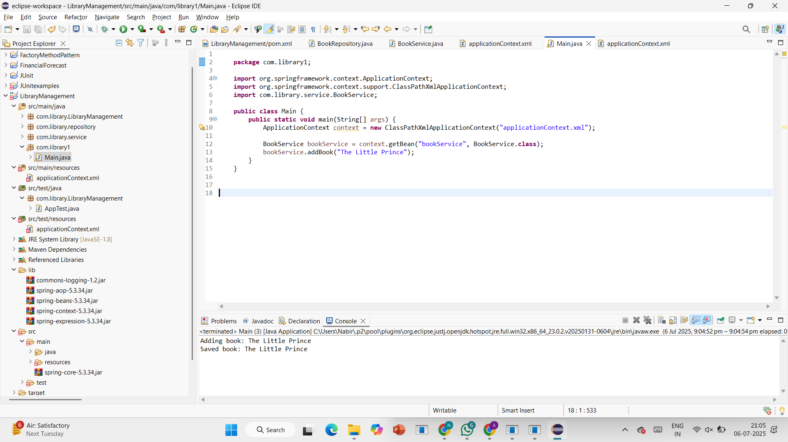

**Exercise 2: Implementing Dependency Injection**

**Scenario:**

In the library management application, you need to manage the dependencies between the BookService and BookRepository classes using Spring's IoC and DI.

**BookRepository.java**

**package** com.library.repository;

**public** **class** BookRepository {

**public** **void** getBooks() {

System.***out***.println("Fetching book list from repository...");

}

}

**BookService.java**

**package** com.library.service;

**import** com.library.repository.BookRepository;

**public** **class** BookService {

**private** BookRepository bookRepository;

// Setter for Dependency Injection

**public** **void** setBookRepository(BookRepository bookRepository) {

**this**.bookRepository = bookRepository;

}

**public** **void** displayBooks() {

bookRepository.getBooks(); // Call a method from repository

}

}

**Main.java**

**package** com.library1;

**import** com.library.service.BookService;

**import** org.springframework.context.ApplicationContext;

**import** org.springframework.context.support.ClassPathXmlApplicationContext;

**public** **class** Main {

**public** **static** **void** main(String[] args) {

ApplicationContext context = **new** ClassPathXmlApplicationContext("applicationContext.xml");

BookService service = (BookService) context.getBean("bookService");

service.displayBooks(); // Should print message from BookRepository

}

}

**applicationContext.xml**

<?xml version="1.0" encoding="UTF-8"?>

<beans xmlns="http://www.springframework.org/schema/beans"

xmlns:xsi="http://www.w3.org/2001/XMLSchema-instance"

xsi:schemaLocation="

http://www.springframework.org/schema/beans

http://www.springframework.org/schema/beans/spring-beans.xsd">

<!-- Define BookRepository bean -->

<bean id="bookRepository" class="com.library.repository.BookRepository" />

<!-- Define BookService bean and inject BookRepository -->

<bean id="bookService" class="com.library.service.BookService">

<property name="bookRepository" ref="bookRepository" />

</bean>

</beans>

**Output:**

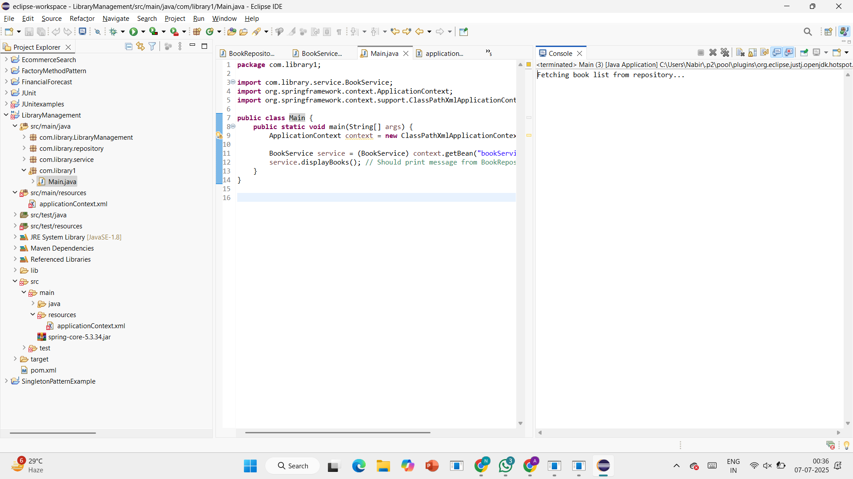

**Exercise 4: Creating and Configuring a Maven Project**

**Scenario:**

You need to set up a new Maven project for the library management application and add Spring dependencies.

**Pom.xml**

<project xmlns="http://maven.apache.org/POM/4.0.0"

xmlns:xsi="http://www.w3.org/2001/XMLSchema-instance"

xsi:schemaLocation="http://maven.apache.org/POM/4.0.0

http://maven.apache.org/xsd/maven-4.0.0.xsd">

<modelVersion>4.0.0</modelVersion>

<groupId>com.library</groupId>

<artifactId>LibraryManagement</artifactId>

<version>1.0-SNAPSHOT</version>

<dependencies>

<!-- Spring Core & Context -->

<dependency>

<groupId>org.springframework</groupId>

<artifactId>spring-context</artifactId>

<version>5.3.30</version>

</dependency>

<!-- Spring AOP -->

<dependency>

<groupId>org.springframework</groupId>

<artifactId>spring-aop</artifactId>

<version>5.3.30</version>

</dependency>

<!-- Spring WebMVC (for future use) -->

<dependency>

<groupId>org.springframework</groupId>

<artifactId>spring-webmvc</artifactId>

<version>5.3.30</version>

</dependency>

</dependencies>

<build>

<plugins>

<!-- Maven Compiler Plugin for Java 1.8 -->

<plugin>

<groupId>org.apache.maven.plugins</groupId>

<artifactId>maven-compiler-plugin</artifactId>

<version>3.8.1</version>

<configuration>

<source>1.8</source>

<target>1.8</target>

</configuration>

</plugin>

</plugins>

</build>

</project>

**BookRepository.java**

**package** com.library.repository;

**public** **class** BookRepository {

**public** **void** getBooks() {

System.***out***.println("Fetching book list from repository...");

}

}

**BookService.java**

**package** com.library.service;

**import** com.library.repository.BookRepository;

**public** **class** BookService {

**private** BookRepository bookRepository;

// Setter for Dependency Injection

**public** **void** setBookRepository(BookRepository bookRepository) {

**this**.bookRepository = bookRepository;

}

**public** **void** displayBooks() {

bookRepository.getBooks(); // Call a method from repository

}

}

**Main.java**

**package** com.library1;

**import** com.library.service.BookService;

**import** org.springframework.context.ApplicationContext;

**import** org.springframework.context.support.ClassPathXmlApplicationContext;

**public** **class** Main {

**public** **static** **void** main(String[] args) {

ApplicationContext context = **new** ClassPathXmlApplicationContext("applicationContext.xml");

BookService service = (BookService) context.getBean("bookService");

service.displayBooks(); // Should print message from BookRepository

}

}

**applicationContext.xml**

<?xml version="1.0" encoding="UTF-8"?>

<beans xmlns="http://www.springframework.org/schema/beans"

xmlns:xsi="http://www.w3.org/2001/XMLSchema-instance"

xsi:schemaLocation="

http://www.springframework.org/schema/beans

http://www.springframework.org/schema/beans/spring-beans.xsd">

<!-- Define BookRepository bean -->

<bean id="bookRepository" class="com.library.repository.BookRepository" />

<!-- Define BookService bean and inject BookRepository -->

<bean id="bookService" class="com.library.service.BookService">

<property name="bookRepository" ref="bookRepository" />

</bean>

</beans>

